Mark Kardash

Professor Hamilton

WRTG393: Advanced Technical Writing

5 November 2022

Texas Roadhouse White Marsh: Ordering a Cheeseburger

Greetings! We at Texas Roadhouse are proud to present to you our online ordering system, designed to get your meal ready faster than ever before. When you order online, you can forget about waiting in line, and grab that deliciousness as soon as you get there. To help you get familiar with this feature, we have prepared a simple set of instructions for how to order an All-American Cheeseburger for pickup.

1. Please visit <https://www.texasroadhouse.com/locations/527-white-marshmd> . Once submitting the search request into the browser, you should be directed to the webpage below:

Figure 1: Texas Roadhouse White Marsh Homepage

1. If you want to create an account, follow the instructions below (If not, skip this step):

* Click on the small person-shaped icon in the top right corner of the page:

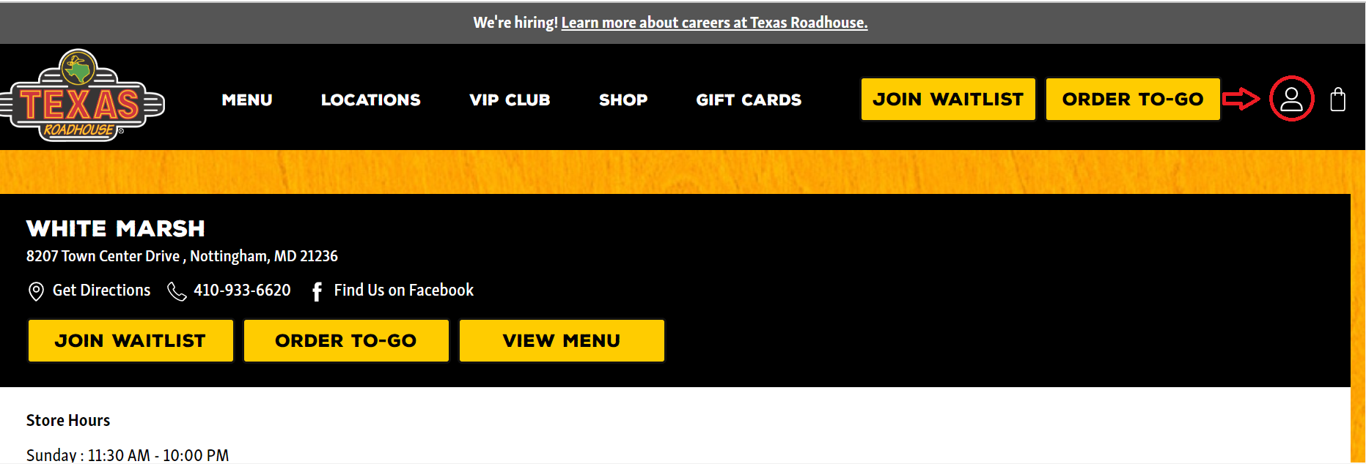

Figure 2: Accessing Account Option

* Once on the “Login” page, click on “Sign Up”:

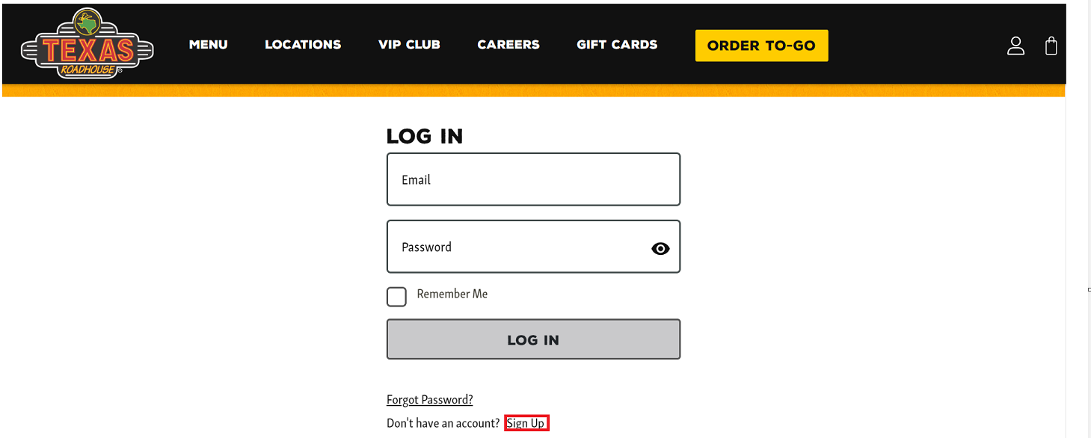

Figure 3: Log-In Page

* On the “Create an Account” page, fill out the required First Name, Last Name, Email, Confirm Email, Mobile Phone, Password, and Confirm Password fields.

Note: Texas Roadhouse only collects and processes your information to ensure the best customer service. You are free to opt out of receiving messages and emails any time.

Figure 4: Filling Out Required Fields

\*If you want, you can also provide us with your favorite location, Zip Code, and birthday, so you can receive special offers. If not, skip those fields.

* Scroll down. BEFORE clicking on “Sign Up”, make sure to uncheck any boxes with options you don’t like, and select any options you prefer. In addition, make sure to read and accept the conditions and privacy policy.

Figure 5: Optional Fields May be Checked or Unchecked

* Click on “Sign in”.

1. Click on “Order to Go”.

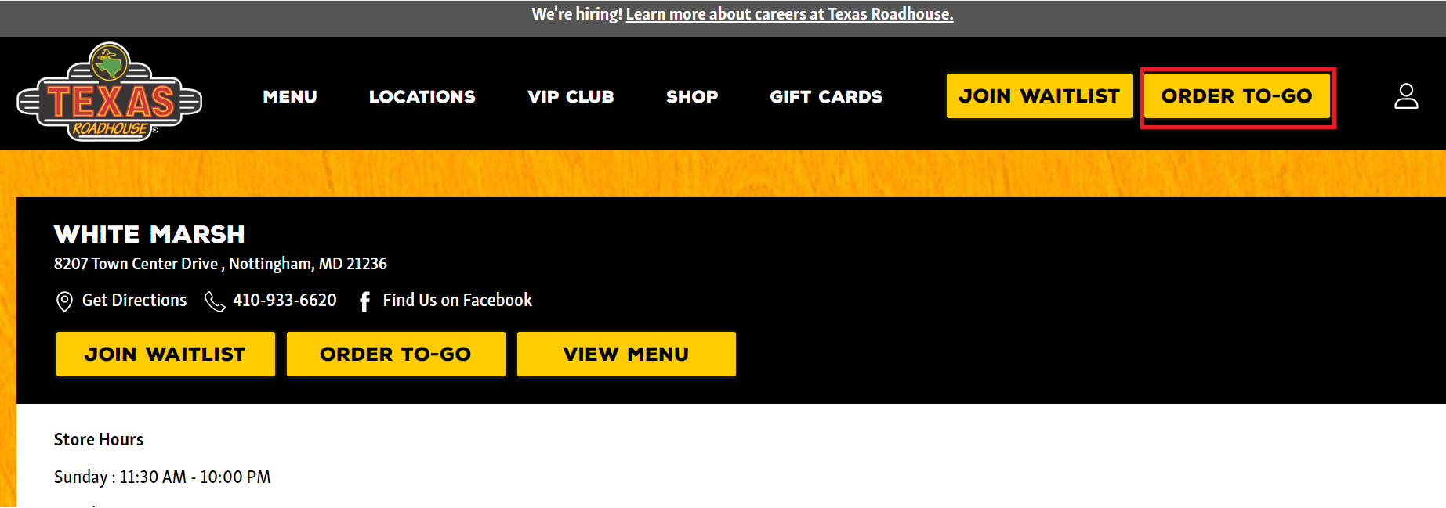

Figure 6: Initiating Order

1. Select the time you want to pick up your meal at. If you don’t see your preferred time, click on “More times” and scroll through the dropdown menu.

Figure 7: Order Time Selection Step 1

1. Scroll down and click on “Continue Order”.

Figure 8: Order Time Selection Step 2

1. Scroll through the menu, selecting “Burgers & Sandwiches”.

Figure 9: Choosing your Category

1. Select whether you want your burger with cheese, its cooking temperatures, and, if you want, add some toppings, one of our delicious sides. If a simple burger will do, move on.

Figure 10: Additional Meal Options

1. Once done with selecting your order, scroll down, and click “Add to Order”.

Figure 11: Adding Meal to Order

1. Select whether you want to include silverware with your order, write any special instructions, or apply a coupon code. If you don’t want to do any of that, scroll down, and click on “Checkout”.

Figure 12: Adding Silverware

1. Fill out the required (\*) fields in the “Information” section. If you do not want to be emailed Texas Roadhouse offers, or texted about your order, make sure to uncheck the two boxes below (Highlighted red).

Figure 13: Checkout & Personal Information

1. Fill out all fields for the method you are paying with. Acceptable payment methods are: Visa, Mastercard, Discover, and American Express. Pay with a Texas Roadhouse Gift Card if you have one.

Figure 14: Checkout & Financial Information

1. Click on “Place Order” when done.

Figure 15: Placing your Order

How My Instructions Accommodate My Personas:

Although I began my instructions with a greater focus on how to best format them, I did take into account my personas, and the pain points that need to be addressed. This starts at Step 2, which is a step I specially included for someone like Lisa Graham, the accountant wanting to make an account (no pun intended) to surprise her son with a burger after a successful football game. I do have a bit of a concern about that, as I practically included a set of instructions WITHIN a set of instructions. In my future draft, I am thinking about replacing the entire account section with a simple “If you want to make an account, check out “Creating an Account”). That will depend on my professor’s advice. Within that step, I include a note assuring the user that their information will be used for their own benefit, and that they can opt out of it any time. This is meant to lessen the stress of both people like Lisa, who doesn’t want to receive advertisements, and John, who is concerned about data safety. I later tell the user to “unselect any boxes” they may not desire. This comes for people like Michael Thomas, who may be too busy to pay attention to such details. It can also be a great stress reliever for Lisa, since she’ll now know subscription to receive offers is voluntary.

Step 4 allows the user to choose a time for picking up their meal, which means Michael wouldn’t need to worry about missing his classes. Step 7 again caters to people like Michael, by clearly saying what they are required to select vs. what they can voluntarily select. On step 10 I once again reminded my “personas” to pay attention to any boxes checked by default. Step 11 includes all the payment methods that are accepted by the restaurant. This enables Michael to pay with Mastercard, Lisa to pay with Discover, and John to use that gift card of his.

I must also say that I encountered some difficulties while making the instructions. The biggest was probably dealing with things like both the Email and Phone number fields being required. Since I couldn’t change the requirements settings of the website itself, I did the next best thing that came to mind, and included notes that Texas Roadhouse doesn’t endanger their customers’ privacy. This in itself was a whole other challenge, as after briefly viewing the restaurant’s privacy policy, I didn’t find anything about not selling customer data, and the website flat out said they do use their customer data for advertisement purposes. To solve this, I simply informed the user they could opt out if they wished.

References:

 Texas Roadhouse (n.d.) White Marsh, MD-Texas Roadhouse

<https://www.texasroadhouse.com/locations/527-white-marshmd>